**Deploy Google Apps Script web app as an Android application**

The main advantage of *serverless* Google Apps Script against of *serverless* Cloud Functions is online editor (IDE) not only for writing code for server-side, but even for client-side. You can create HTML web application with [HTMLService](https://developers.google.com/apps-script/guides/html/)

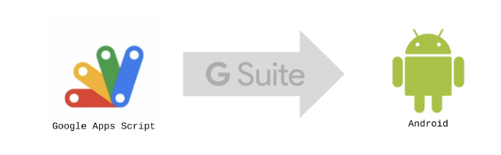

Google has recently introduced option to deploy web application as a *native* Android application for G Suite users. If you are reading this, you are probably power-user so you can imagine what you are able to do now! Yes, deploy native Android application with Google Apps Script.  
  
Notes:  
-To use web apps, your user’s devices must have Google Chrome installed  
  
1) Create a new Script at [**https://script.google.com**](https://script.google.com/)  
  
2) Insert code snippet into code.gs

|  |  |
| --- | --- |
|  | function doGet(e) { |
|  | return HtmlService.createTemplateFromFile("view").evaluate(); |
|  | } |

3) Create a new HTML file and rename it to "**view.html**"

[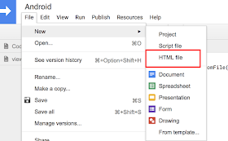](https://4.bp.blogspot.com/-pXnEHBBS6gk/XEdPeqpvs1I/AAAAAAACRr4/VmeSF9sYMkIGgelJI6x7xxYUjrV-N35EwCLcBGAs/s1600/android.png)

4) Edit HTML for your future über-cool-application (just for now, insert Hello World!)  
  
5) Open menu **Publish --> Deploy as web app**and copy **URL address**

[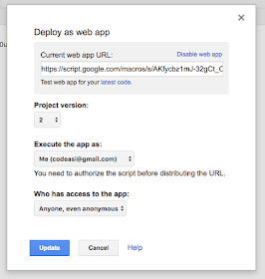](https://1.bp.blogspot.com/-Q3BbaZ2ZrSo/XEdPoJcCNYI/AAAAAAACRr8/u3R88ton_X044hkfZyRieM5i8mgFJmSmACLcBGAs/s1600/deploy.png)

6) It is time setup in G Suite. Open Google Admin console ([**https://admin.google.com**](https://admin.google.com/)**)** and pick category **Device management**

[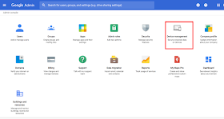](https://4.bp.blogspot.com/-rrXVuF_v-VY/XEdD96JGO0I/AAAAAAACRqg/AukgWB8bHUkXtGDXHS0mcrDH_EMt50w_gCLcBGAs/s1600/admin_console.png)

7) Then choose **App Management** from left panel.

[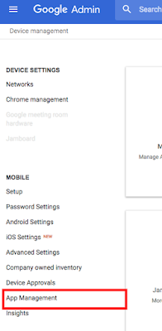](https://1.bp.blogspot.com/-zWGdl24CqIc/XEdD_MFihsI/AAAAAAACRqk/pCLA4FZsKb07btA0c5FNj3h2oOVGYYnIwCLcBGAs/s1600/app_mgmt.png)

 8) In App Management you will see section in the middle of page -**Manage apps for Android devices.**This section contains button **Manage whitelisted apps.**Click it.

[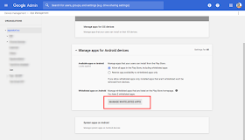](https://1.bp.blogspot.com/-mru_Funp89k/XEdEA3fff_I/AAAAAAACRqo/dszbkDWqjHAkVC92MrVsguKPuCNPa--pACLcBGAs/s1600/whitelisted.png)

9) Now you are in mobile application management. First, you must Add a new whitelisted application (with yellow circle button)

[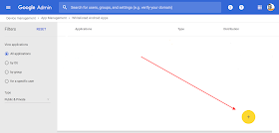](https://3.bp.blogspot.com/-PlT_ziIVOmM/XEeCv7qjipI/AAAAAAACRsk/u-kiROUFxEgIKWvPCeWVs4voSG50yJ6SwCLcBGAs/s1600/whitelisted2.png)

10) You will see Google Play directory. Change category (left panel) to **Web Apps.**

[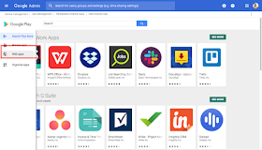](https://4.bp.blogspot.com/-nqbOo_KBkYU/XEdEB6yLGPI/AAAAAAACRqs/jHFZGdvApOMMBHranCm8Hyzw8ydslXe0ACLcBGAs/s1600/web_apps.png)

11) For now, you must again click at **Add** button (circle button at right bottom of page.

[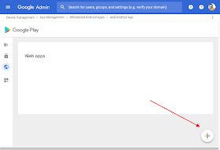](https://1.bp.blogspot.com/-O-JoRhG0rn0/XEdRXIBMzpI/AAAAAAACRsM/nL086XTFt3w5RlmNpOBz_SksAg5G1fGuQCLcBGAs/s1600/circle.png)

12) Now you can define behavior of your Android application.  
- Title is name of application on home screen  
- URL of your Google Apps Script (from step 5)  
- I recommend you for display choose **Full screen**or **Standalone**  
- Icon of your Android application

[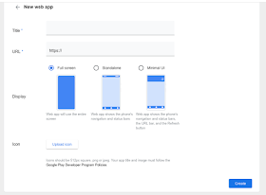](https://1.bp.blogspot.com/-GMTvkA_3jC0/XEdGHBbKjXI/AAAAAAACRrE/gxAkMQJ1kdAu-fkTCc9FCdk3rPkg0J3lgCLcBGAs/s1600/new-app.png)

13) After you click at Create button it will take about 10 minutes to prepare your application.  
(There is a small text Not available yet below during preparation )  
  
14) When your application is successfully prepared, then you can click at desired icon

[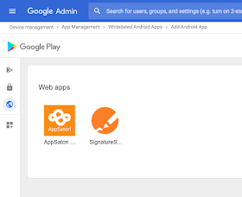](https://3.bp.blogspot.com/-7_BINBaz_wo/XEdMPd5909I/AAAAAAACRrk/rz-4r9chkugjiIRiegd1Nsw9mgtlJ-VEwCLcBGAs/s1600/ready.png)

[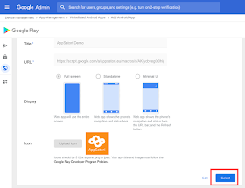](https://4.bp.blogspot.com/-YnCqX5b1_N4/XEdMzb7T7FI/AAAAAAACRrs/rYtgrUzzU045xPvDpKZOva7rhFIQE_hXwCLcBGAs/s1600/select.png)

15) During distribution strategy, you can distribute application for all G Suite users or subset according to Organization unit.

[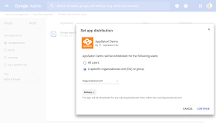](https://2.bp.blogspot.com/-pK7AZLWPVHM/XEdKhYnKu4I/AAAAAAACRrQ/X_AMQYqntxoyWJCcCg5xKUlK7CiQ2WZ5QCLcBGAs/s1600/distribution.png)

16) Last step contains option to automatically install application on all devices (This option does not work for me)

[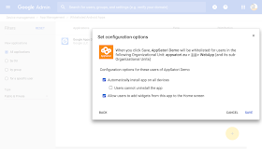](https://3.bp.blogspot.com/-t6cVPCwUOvU/XEdLIdUp5qI/AAAAAAACRrY/rARw6QddwFA69m70boJWvRLkd-D4FndHwCLcBGAs/s1600/distribution%2B2.png)

17) When you visit Google Play at your phone, then navigate to section **Work Apps.**Click to application and install it.

[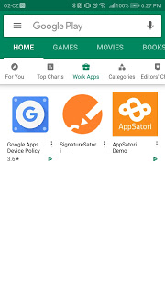](https://3.bp.blogspot.com/-9dc2__mdzBw/XEdSvD_1rhI/AAAAAAACRsY/t_ctEK9lrMgc079g3cuIlkuppD-4ew7hQCLcBGAs/s1600/play.jpg)

The was a final step. Your Google Apps Script application is on mobile's home screen